HOW TO USE THE COURSE

How to use the Course
The Tax Lien and Deed Educational Programs are structured in a way that each lesson breaks down the process of doing "Your Diligence," which, while moving through the program, the learner can practice while completing each section. This is a very useful course that can help anyone get into the process of tax lien and deed investment.
Our course covers many aspects of tax lien and deed investment. Please keep in mind that this program is packed with information, so please don't be overwhelmed. Take your time and move at your own pace. But please get moving; we want you to win and get the most out of the program.

Step 1
Now that you are logged onto the platform, it is time to enter your selected course. If you have purchased the full course, you have access to the "Introduction Program & Full Program." We do advise that if you are a new learner to this method, start with the introduction program and then move on to the full course.
- On the right side of the screen, there is a tab that you can click to get to know more.

Figure 1: This is where you can navigate your Special Access. (Drop Tab)

- Get to know the Tab
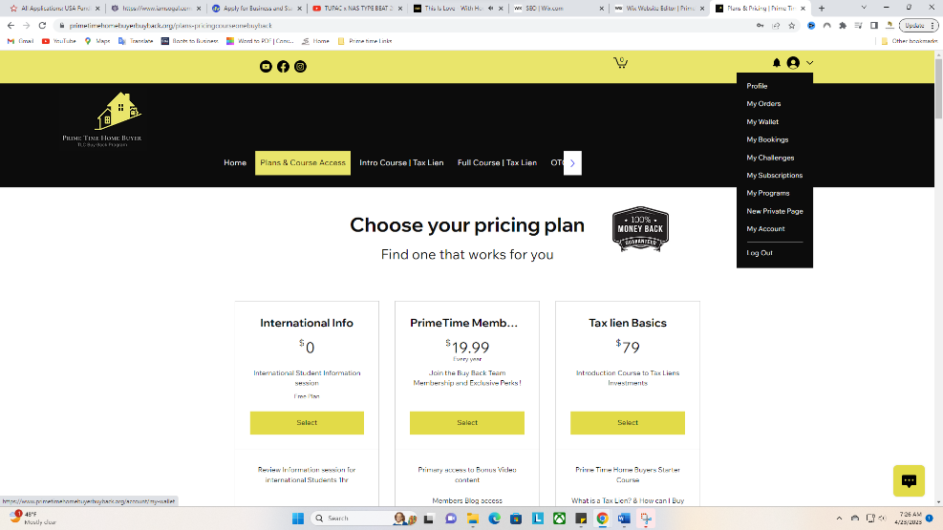

Step 2
- Sign into your Course
- Click on the Tab ~ My Program
- The screen at the bottom will show.
- You will only see the “View program” tab, if your not already in the program
- Click on the Tab ~ View program.”
- Please review video for step-to-step breakdown

How To Access Your Prime Time Seminars/ Course | The Buy Back Team
Click on the Link to learn how to access your prime time seminars/course.
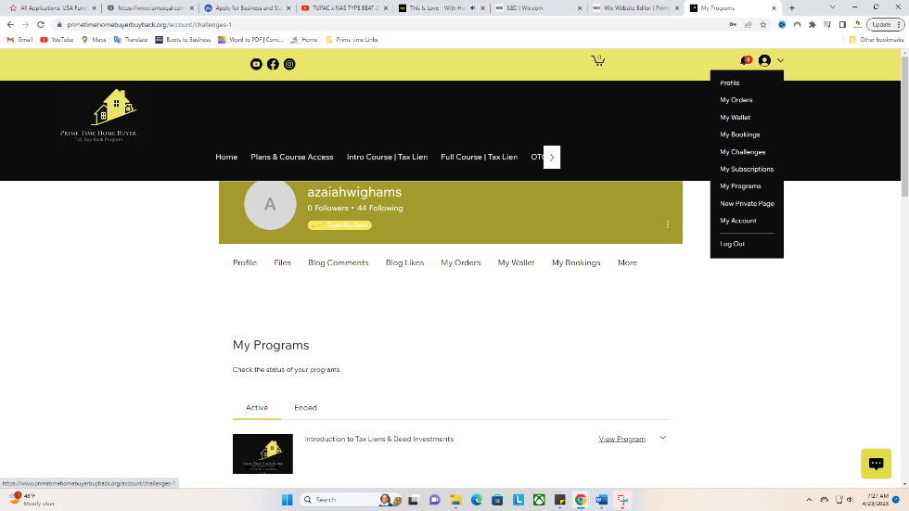

Now that you’re in the Course lest get started.
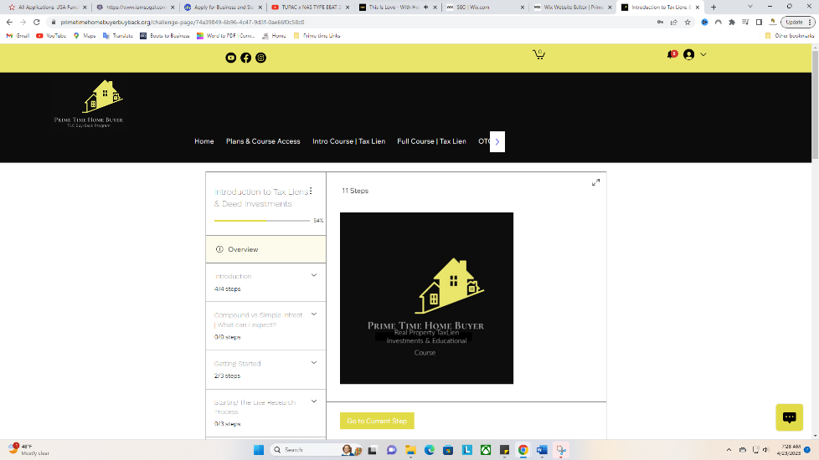

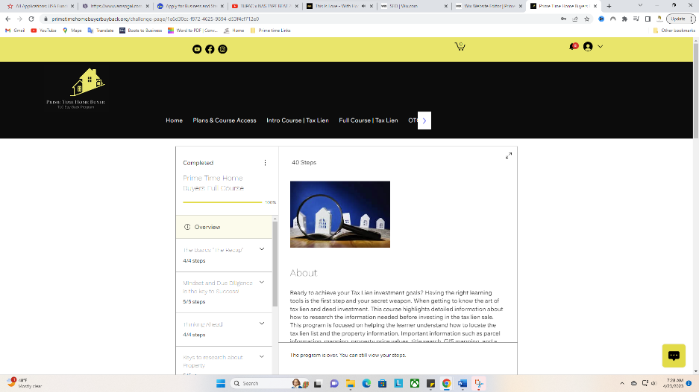

How to be Successful in the Program: 4 Steps
- Take your time and move step by step through the program.
Try not to skip steps, this will ensure you have a good understanding of the process and how to mitigate risk.
- Use all your resources (PDF, Power point and video)
This content is located under the “Files Tab.”
- Try the process while you learn.
Start by doing your due diligence before investing.
Use googles to get started, remember at least 70% of the process is done online. If you are doing the Over-the-Counter method. Most of your process will be done online.
- Look into your state of interest as a case study to get to know the process.
Start here (Click here)
Also use the student Resource and study Hall to get more resources.

